

**SCHOOL OF INFORMATION TECHNOLOGY AND ENGINEERING**

**FALL SEMESTER –2022-23**

**M.Tech (SE)**

**CAPSTONE  PROJECT**

**FINAL  REVIEW**

**TOPIC:**

**GLAUCOMA PREDICTION SYSTEM**

**REG.NO :  18MIS0277**

**NAME    :   VIGNESH.P**

**GUIDE: SUBHA S**

**ABSTRACT:**

**The disorder that results in the damage of the optical nerves in the eye which are responsible for transmitting images to the brain is called Glaucoma. It is related to the retina and one of the most common cause for the permanent blindness in the people blindness. It is an non- curable disease. There are no early symptoms of glaucoma and the only source to detect glaucoma at an early stage is the structural change that arises in the internal eye. There is fluid in the eye called aqueous humor that flows through the pupil and in the case of the glaucoma the fluid is clogged and it mainly effect the optical disk where the size of the optical cup increases resulting in high cup-to disk ratio. Convolution neural network technique is recursively applied .From the digital image of the eye we can find the Glaucoma.**

**Glaucoma can permanently damage the vision the effected eyes and leads to the blindness if left untreated. An early and accurate detection of glaucoma is one of the major requirements to stop glaucoma progression. Fundoscopy and Optical Coherence Tomography (OCT) are two modern medical imaging techniques which enables the ophthalmologists to analyze the internal structural retinal details.**

**Fundoscopy is a technique which reveals the internal fundus details. The devices used by ophthalmologists like Heidelberg Retinal Tomography(HRT) and Optical Coherence Tomography (OCT) consists of the same and accurate information as the image captured by digital fundus camera but these devices are costly we have to reduce to cost efficient and accurate method for detecting the glaucoma from the digital fundus images. A healthy optic nerve possesses abundant nerve fibers traveling through it and it is usually appeared as a small cup. Hence, the proportion of a cup diameter with respect to its optic disk diameter is often described by the ophthalmologist and named as a “cup to disc ratio”. By identifying the cup-to-disk ratio in the images we find the glaucoma is detected or not by the size of it. Region between the disc and cup is called Neuroretinal Rim (NRR). Along with CDR and NRR, image intensity based features can be used in glaucoma detection systems in leading to more accurate glaucoma detection.**

**Problem definition:**

**Glaucoma is a chronic and irreversible disease characterized by degeneration of optic nerve cells which changes the optic nerve head and visual field. According to the World Health Organization survey, glaucoma is the second leading cause of blindness. Glaucoma is a potentially blinding disease which is affecting more than 66 million persons worldwide. Glaucoma when compared to other diseases progresses with no pains or any other noticeable symptoms. Glaucoma is an ocular disorder which might leads to permanent vision loss if not detected at an early stage. Origin of glaucoma is the increase in intraocular pressure (IOP) which if continues, destroys the optic nerve. Glaucoma is an eye disease which occurs due to the increased or decreased fluid pressure inside the eye as the pressure inside the normal eye is below 21mm of Hg, when the pressure inside the eye increases more than this value optic nerve will be damaged .**

**Glaucoma can permanently damage the vision the effected eyes and leads to the blindness if left untreated. An early and accurate detection of glaucoma is one of the major requirements to stop glaucoma progression. Fundoscopy and Optical Coherence Tomography (OCT) are two modern medical imaging techniques which enables the ophthalmologists to analyze the internal structural retinal details.**

**Fundoscopy is a technique which reveals the internal fundus details. The devices used by ophthalmologists like Heidelberg Retinal Tomography(HRT) and Optical Coherence Tomography (OCT) consists of the same and accurate information as the image captured by digital fundus camera but these devices are costly we have to reduce to cost efficient and accurate method for detecting the glaucoma from the digital fundus images. A healthy optic nerve possesses abundant nerve fibers traveling through it and it is usually appeared as a small cup. Hence, the proportion of a cup diameter with respect to its optic disk diameter is often described by the ophthalmologist and named as a “cup to disc ratio”. By identifying the cup-to-disk ratio in the images we find the glaucoma is detected or not by the size of it.**

**Region between the disc and cup is called Neuroretinal Rim (NRR). Along with CDR and NRR, image intensity based features can be used in glaucoma detection systems in leading to more accurate glaucoma detection.**

**OBJECTIVES:**

**. To develop and to propose a machine learning model for predicting glaucoma and identifying its risk factors.**

**.** **To develop  disorder that results in the damage of the optical nerves in the eye which are responsible for transmitting images to the brain is called Glaucoma.**

**.** **It is related to the retina and one of the most common cause for the permanent blindness in the people blindness.**

**.** **Convolution neural network technique is recursively applied From the digital image of the eye we can find the Glaucoma.**

**SCOPE OF THE PROJECT:**

**Fundoscopy and Optical Coherence Tomography (OCT) are two modern medical imaging techniques which enables the ophthalmologists to analyze the internal structural retinal details.**

**Fundoscopy is a technique which reveals the internal fundus details. The devices used by ophthalmologists like Heidelberg Retinal Tomography (HRT) and Optical Coherence Tomography (OCT) consists of the same and accurate information as the image captured by digital fundus camera but these devices are costly we have to reduce to cost efficient and accurate method for detecting the glaucoma from the digital fundus images. A healthy optic nerve possesses abundant nerve fibers traveling through it and it is usually appeared as a small cup. Hence, the proportion of a cup diameter with respect to its optic disk diameter is often described by the ophthalmologist and named as a “cup to disc ratio”. systems in leading to more accurate glaucoma detection.**

**ARCHITECTURE DIAGRAM:**

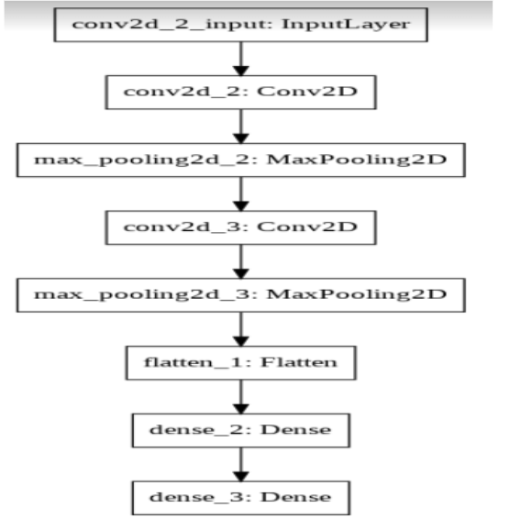

**LITERATURE SURVEY:**

**Review on various schemes**

**Paper 1 (2016): Adaptive threshold based technique:**

**The conventional methods for glaucoma detection are very costly for the detection of the glaucoma in the eyes. Glaucoma is the severe eye diseases in the aged people. The devices used by ophthalmologists like Heidelberg Retinal Tomography (HRT) and Optical Coherence Tomography (OCT) consists of the same and accurate information as the image captured by digital fundus camera. Glaucoma produces varies in shape, color, depth of optic disk which helps in its identification. Digital fundus images are analyzed in two phases**

**1. vessel detection and in panting**

**2. comprises of CDR calculation**

**We use thresholding method for the system. The adaptive threshold based technique for the automated segmentation of optic disk and cup can be useful in the early detection of glaucoma to curb permanent loss of vision. The thresholding technique used in this paper is robust and effective because it uses the image features like mean and standard deviation and does not depend on factors such as image contrast, brightness, intensity of light etc**

**Paper 2 (2017): Wavelet features of segmented optic disc from fundus images Glaucoma is a disease that is related to retina and one of the most common cause for the permanent blindness in the people worldwide. We used wavelet feature extraction which has been followed by optimized genetic feature selection combined with several learning algorithms and various parameter settings. The feature extraction from the segmented and blood vessel removed optic disc to improve the accuracy of identification. In proposed method of glaucoma detection involves wavelet feature extraction and analysis of segmented optic disc image. Optic disc is automatically differed from the fundus image and then wavelet features are extracted for analysis and classification. To segment the optic disc from the digital fundus image, initially the center of the optic disc is localized and then optic disc is segmented using bit plane analysis. Center of the optic disc is calculated using a double windowing method. Automatic image analysis based system is proposed for detection of glaucoma from the digital fundus image using wavelet features from the segmented optic disc. From the results we can find that we have 94.7% accuracy using first level wavelet features from segmented and blood vessels in-painted optic disk image.**

**Paper 3 (2017): Detection using feed forward network**

**Glaucoma is a disease of the eye which accounts for 10% of blindness in the world and occurs in 2% to 3% of the American population over the age of 35.There is gradual visual field loss during the progression of the disease and there is a characteristic type of damage to the retinal nerve fiber layer**

**associated with glaucoma. The disease is most easily controlled when diagnosed at an early stage. It would be useful to have an accurate, sensitive, and specific method of screening for the disease. The type of artificial neural network used was a feed forward error back propagation ANN. These are known for an ability to memorize patterns, and with techniques outlined in are able to generalize well. The ANN structure consisted of a three layer net with fourteen input nodes, one hidden layer, one output node, and a bias unit connected to the hidden and output units. Helps in ophthalmologists to diagnose glaucoma using quantitative measurements of the ONH, minimizing the stress from the testing procedure. Used HRT measurements of the OH, was able to separate glaucomatous from healthy ONHs with a high degree of accuracy.**

**Paper 4 (2017): Automatic fundus image cup-to-disc ratio measurement system**

**This present an automatic fundus image based cup-to-disc ratio measurement system, and demonstrate**

**its potential for automatic objective glaucoma diagnosis and screening. Glaucoma is the second leading cause of blindness worldwide with estimation of 60 million according to 2010.Unlike other eye diseases like cataract and myopia, glaucoma cannot be cured as the damage of the optic nerve is permanent, and any treatment is unable to restore vision. Early detection is thus necessary for early treatment to prevent the deterioration of the vision. Clinically, the following three examinations are currently practiced to detect glaucoma:**

**• Intraocular pressure (IOP) measurement**

**• Visual field test**

**• Optic nerve assessment.**

**Optic disc assessment by an ophthalmologist is subjective and the availability of OCT/HRT is limited because of the cost involved. The 2D fundus digital image is taken by a fundus camera, which photographs the retinal surface of the eye. In comparison with OCT/HRT machines, the fundus camera is easier to operate, less costly, and is able to assess multiple eye conditions. The CDR (Cup-to-Disc Ratio)**

**is defined as the ratio of the vertical cup height divided by the vertical disc height: CDR=cup height / Disc height. In order to calculate the CDR, we need to segment both the optic disc and optic cup from the fundus images. A large CDR denotes a higher risk of having glaucoma, and the following algorisms are used:**

**• Image segmentation algorithm.**

**• Level set algorithm.**

**• Algorithm on optic cup segmentation (CDR).**

**• ASM algorithm**

**Paper 5 (2018): Glaucoma risk index from fundus images**

**Glaucoma as a neuro degeneration of the optic nerve is one of the most common causes of blindness. Because revitalization of the degenerated nerve fibers of the optic nerve is impossible early detection of the disease is essential. Glaucoma leads to**

**I. structural changes of the optic nerve head (ONH) and the nerve fiber layer and**

**II. a simultaneous functional failure of the visual field.**

**The glaucoma disease is characterized by the degeneration of optic nerve fibers and astrocytes that is often accompanied by an increased intraocular pressure. The proposed two-stage classification scheme helps to combine classifiers of different image inputs. The evaluation showed that this assembly improves the certainty of the classification and it makes the final decision more robust. Established methods early reduce the amount of feature dimensionality by using parametric models or structural measurements.**

**Paper 6 (2018) : detection using structural and non structural features**

**The proposed technique provides a algorithm to detect glaucoma from digital fundus image using a hybrid feature set. In this paper we there is a combination of cup-to-disk i.e structural and textural and intensity i.e non-structural features. In the proposed method there is a suspect class in automatic diagnosis in case of any conflict in decision from structural and non-structural features. The system is designed to refer glaucoma cases from rural areas to specialists and the motivation is to ensure high sensitivity of the system.**

**The fundus images are per processed before cup and disc detection to extract the Region of interest (ROI). The ROI extraction reduces the time complexity of algorithm by processing the only wanted regions. To remove the unwanted noise ROI is extracted from the fundus image to proceed further. Image is converted to binary image using a threshold value which selects 40 % of the bright pixels from image. All the detected blobs are the candidate regions for optic disc. Region with largest vessels density is finally selected as the optic disc location. Taking center of detected disc from candidate region, an area is cropped to extract ROI. CDR, ISNT ratio, NRR ratio, Vertical and horizontal Cup height are the main fundamental structural changes that appear in case of glaucoma progression and which are identified by all the autonomous glaucoma detection systems.**

**Paper 7 (2018) : A automatic fundus image analysis system**

**The criteria for the glaucoma are intraocular presser measurement, optical head evaluation, nerve fibre layer and visual field defect. The broad range of cup to disc ratio is difficult to identify early changes of optic nerve head, and different ethnic groups possess various features in optic nerve head structures. We developed an automatic detection system which contains two major phases**

**1. The first phase performs a series modules of digital fundus retinal image analysis including vessel detection, vessel inpainting, cup to disc ratio calculation, and neuro-retinal rim for ISNT rule**

**2. The second phase determines the abnormal status of retinal blood vessels from different aspect of view. The important features in this system is to measure the cup-to-disk ratio, neuro-retinal rim configuration and vessel distribution. They are extracted through the designed sequential modules. The initial step is to detect vascular by two structural characteristics that are shape and continuity and the next step is local peak thresholding analysis from histogram of an inpainted image is performed for region segmentation and each image will be segmented into three major regions. Three segmented regions are circularly fitted with two circles to obtain initial boundaries within the optic disc regions. The automatic glaucoma detection system is designed through the vessel detection, CDR parameter calculation and ISNT rule analysis. This helps in early diagnosis of glaucoma and the follow-up evaluation**

**Paper 8 (2018 ): Detection from topographic features of optic nerve in images**

**The presented machine-learning–based automatic glaucoma system requires a set of labelled fundus photograph examples consisting of both normal and glaucomatous eye categories to learn about each individual category to perform classification. In this paper presented an automated system for glaucoma detection, which is comparable in performance to classification based on color fundus images by trained ophthalmologists. Although this indicates the potential for the system to be used in glaucoma screening, for effective population based screening, however, the system needs to be validated in a larger sample of fundus images. These images need to be with varied optic disc appearances and morphology obtained by nonmydriatic cameras to be representative of the screening populations. The suspect category was merged with the confirmed glaucomatous category for the evaluation of the proposed system with the assumption that those cases also need a clinical examination and monitoring by a glaucoma expert.**

**Paper 9 (2018) :fundus images classification for detection**

**Glaucoma is a neurodegenerative illness and is considered as a standout amongst the most widely recognized reasons for visual impairment. This article audits a few division and segmentation methodologies that are exceptionally useful for recognizable proof, identification, and diagnosis of glaucoma. Glaucoma amongst retinal diseases is the most common and prominent reason for vision loss that ultimately leads to blindness. Glaucoma is caused by the increased IOP in eyes and hence considered as among one of the reasons for vision misfortune that in the long run prompts visual impairment. The researchers found that 17% people with hypertension, 35% persons with diabetes and 48% people having both hypertension and diabetes were more prone to developing OAG. The detection methods start with noise removal upgrade/enhancement taken after by feature extraction, feature optimization and afterwards at last recognizable proof of the presence of glaucoma. For glaucoma detection method mfERG and Optical coherence tomographyare used to compute the progression detection of glaucoma, examining functional and structural and to observe inconsistency in the eyes accurately. Glaucoma is one of the neurodegenerative maladies and is considered as one of the most widely recognized reasons for the visual impairment. Degeneration of nerves is an irreversible procedure, so the early finding of the illness is inescapable to maintain a strategic distance from lasting loss of vision**

**Paper 10 (2019):**

**automatic cup to disk ratio using retinal images:**

**Glaucoma is a leading cause of permanent blindness. However, disease progression can be limited if detected early. The optic cup-to-disc ratio (CDR) is one of the main clinical indicators of glaucoma, and is currently determined manually, limiting its potential in mass screening. In this paper, we propose an automatic CDR determination method using a variation level-set approach to segment the optic disc and cup from retinal fundus images.**

**Threshold analysis is used in preprocessing to estimate the initial contour. we have presented a method to calculate the CDR from fundus images using a level-set-based technique. After obtaining the contours, an ellipse fitting step was introduced to smooth the obtained results, which is less computationally expensive as compared to other approaches. 104 retinal images were processed and their CDR was calculated. It was shown that this gives a 96% confidence of obtaining results within a range of ±0.2, which is within the variability for manually graded CDR values. The results indicate promising potential for our method to be used in ARGALI for the mass screening of patients for glaucoma.**

**Dataset Specification:**

**In our project we are using kaggle dataset .All these 1000 fundus images which belong to 39 classes are come from kaggle dataset. Color-filtered fundus images visualize the rear of an eye called retina .Fundus image provides doctors with a snapshot on the interior of the eye of patients. Based on**

**this type of image, doctor will be able to read abnormalities present on the back of the eye, thus making diagnosis easier and more accurate. Many eye diseases can be found using fundus images, such as diabetic retinopathy, glaucoma, and macular degeneration.**

**Kaggle allows users to find and publish data sets, explore and build models in a web-based data-science environment, work with other data scientists and deep learning engineers, and enter competitions to solve data science challenges.**

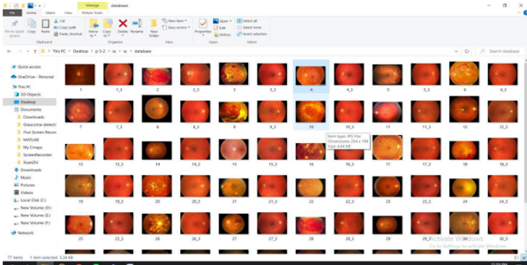

**We have downloaded dataset from browser**

**Source:** [**https://www.kaggle.com/linchundan/fundusimage1000**](https://www.kaggle.com/linchundan/fundusimage1000)

**Detailed Description of Modules:**

**Data collection:**

**Fundus images were collected from dataset named kaggle. We included patients with glaucoma who had primary open-angle (either high- or low-tension glaucoma), pseudoexfoliative or pigmentary glaucoma. Glaucoma patients were diagnosed clinically on the basis of characteristic structural losses observed on dilated stereoscopic examination of the optic nerve head.**

**Preprocessing of data:**

**Prior to developing the deep leaning architecture we normalized all the images and frames and then marked the center of the optic disc in all of the frames in each image. An algorithm (was then applied to crop all images to a square region centered on the optic disc**

**Convolutional neural network (CNN): extracting spatial features from retinal images:**

**The pre-processed image is given as an input to the CNN model which consists of an input layer, convolution layers and a fully connected layer. The input image of 256x256pixel acts as the input layer. In the first convolution layer, 16 filters of 3x3 size kernels each are applied to the input image by gliding one by one through the position and a total of 16 feature maps are generated. This method is called as**

**feature extraction. These features are then applied to the ReLU activation function, which performs a threshold operation for each input variable with values below zero**

**Max pooling:**

**A pooling operation that selects the maximum element from the region of the feature map covered by the filter. Thus, the output after max-pooling layer would be a feature map containing the most prominent features of the previous feature map.**

**Network training:**

**We evaluated the networks described earlier using transfer learning. In transfer learning, as opposed to native training, model weights are initialized based on the ImageNet dataset, a large benchmark dataset in object category classification and detection on hundreds of object categories and millions of images.**

**Transfer learning is to initialize the model weights based on a huge general image dataset, except for the fully connected layers which are trained on our constructed fundus dataset.**

**Software Requirement Specifications:**

**•Operating system: Windows 10/9/8**

**•Coding Language: python code**

**•Tool: jupyter notebook- keras, matplotlib, tensorflow, numpy, seaborn, pydot, graphviz**

**Experimental Results & Discussion:**

**In this work a total of fundus images of the patients with age ranging from 25 to 60 years were used. Out of these twenty four are normal and thirty seven were glaucoma cases. Features such as cup to disc ratio, optic nerve head shift and ISNT ratio were computed for both normal and glaucoma samples using the techniques discussed above. We can see that cup to disc ratio and optic nerve head shift is more for the glaucoma due to the increase in the pressure. The ratio of the sum of blood vessels area in inferior and superior regions to area of blood vessels in sum of nasal and temporal regions is lower for subjects having glaucoma. A Student t-test was conducted on these two groups for different parameters and it was found that the p value is less than 0.05. This indicates that all features detected for these two groups are statistically significant.**

**CODE:**

**import os**

**print(os.listdir((r"C:\Users\welcome\Desktop/gd")))**

**from keras.models import Sequential from keras.layers import Conv2D**

**from keras.layers import MaxPooling2D**

**from keras.layers import Flatten**

**from keras.layers import Dense**

**# Initialising the CNN**

**classifier = Sequential() # Step 1 - Convolution**

**classifier.add(Conv2D(32, (3, 3), input_shape = (256,256, 3), activation = 'relu'))**

**# Step 2 - Pooling**

**classifier.add(MaxPooling2D(pool_size = (2, 2)))**

**# Adding a second convolutional layer**

**classifier.add(Conv2D(32, (3, 3), activation = 'relu'))**

**classifier.add(MaxPooling2D(pool_size = (2, 2)))**

**# Step 3 - Flattening**

**classifier.add(Flatten())**

**# Step 4 - Full connection**

**classifier.add(Dense(units = 128, activation = 'relu'))**

**classifier.add(Dense(units = 1, activation = 'sigmoid'))**

**# Compiling the CNN**

**classifier.compile(optimizer = 'adam', loss = 'binary_crossentropy', metrics = ['accuracy'])**

**from keras.preprocessing.image import ImageDataGenerator**

**train_datagen = ImageDataGenerator(rescale = 1./255,**

**shear_range = 0.2,**

**zoom_range = 0.2,**

**horizontal_flip = True)**

**# print(train_datagen)**

**test_datagen = ImageDataGenerator(rescale = 1./255)**

**training_set= train_datagen.flow_from_directory(r'C:\Users\welcome\Desktop/gd/train',**

**target_size = (256,256),**

**batch_size = 32, class_mode = 'binary')**

**# print(test_datagen)**

**test_set = test_datagen.flow_from_directory(r'C:\Users\welcome\Desktop/gd/validation',**

**target_size = (256,256),**

**batch_size = 32, class_mode = 'binary')**

**history = classifier.fit(training_set, validation_data = test_set,batch_size=32,epochs=30, verbose=2)**

**# evaluate the model**

**_, train_acc = classifier.evaluate(training_set, verbose=0)**

**_, test_acc = classifier.evaluate(test_set, verbose=0) print(" Train_accuracy: ", train_acc)**

**print(" Test_accuracy: ", test_acc)**

**### Performance evaluation #########################**

**score = classifier.evaluate(test_set) print(" Total: ", len(test_set.filenames))**

**print("Loss: ", score[0], "Accuracy: ", score[1])**

**# plot loss during training**

**import matplotlib.pyplot as pyplot**

**pyplot.subplot(211)**

**pyplot.title('Model Loss')**

**pyplot.ylabel('Loss')**

**pyplot.xlabel('Epoch')**

**pyplot.plot(history.history['loss'],label='train')**

**pyplot.plot(history.history['val_loss'],label='test')**

**pyplot.savefig(r'C:\Users\welcome\Desktop/gd/LossMaxPooling.png')**

**pyplot.legend()**

**pyplot.show()**

**# plot accuracy during training**

**pyplot.subplot(212)**

**pyplot.title('Model Accuracy')**

**pyplot.ylabel('Accuracy') pyplot.xlabel('Epoch')**

**pyplot.plot(history.history['accuracy'],label='train')**

**pyplot.plot(history.history['val_accuracy'],label='test')**

**pyplot.savefig(r'C:\Users\welcome\Desktop/gd/AccuracyMaxPooling.png') pyplot.legend()**

**pyplot.show()**

**classifier.save(r'C:\Users\welcome\Desktop/gd/GmodelCNNMaxPooling.h5')**

**import os**

**from keras.models import load_model from PIL import Image**

**from keras.preprocessing import image import numpy as np**

**import cv2**

**target_size=(256,256)**

**model=load_model(r'C:\Users\welcome\Desktop/gd/GmodelCNNMaxPooling.h5') print("model**

**loaded")**

**import numpy as np**

**from keras.preprocessing import image**

**test_image=image.load_img(r'C:\Users\welcome\Desktop/gd/train/glaucoma/ROI -**

**image198prime0.jpg.png', target_size = (256,256))**

**test_image=image.img_to_array(test_image)**

**test_image = np.expand_dims(test_image, axis = 0) result = model.predict(test_image)**

**training_set.class_indices**

**if result[0][0] == 1:**

**print("Not Glaucoma") else:**

**print("Glaucoma")**

**import numpy as np**

**from keras.preprocessing import image test_image =**

**image.load_img(r'C:\Users\welcome\Desktop/gd/train/not_glaucoma/ROI - 8421_right.jpeg.png',**

**target_size = (256,256))**

**test_image = image.img_to_array(test_image) test_image = np.expand_dims(test_image, axis = 0)**

**result = model.predict(test_image)**

**training_set.class_indices if result[0][0] == 1: print("Not Glaucoma") else:**

**print("Glaucoma")**

**from numpy import array**

**from keras.models import Sequential from keras.layers import Dense**

**from matplotlib import pyplot classifier.compile(**

**optimizer='adam', loss='mean_squared_error', metrics=[**

**'MeanSquaredError', 'AUC',]**

**)**

**history = classifier.fit(training_set, validation_data = test_set, epochs=30, batch_size=32, verbose=2)**

**#mean-square error pyplot.subplot(212)**

**pyplot.title('Model Mean-square Error')**

**pyplot.ylabel('Mean-square Error')**

**pyplot.xlabel('Epoch')**

**pyplot.plot(history.history['mean_squared_error'])**

**pyplot.savefig(r'C:\Users\welcome\Desktop/gd/MSEMaxPooling.png')**

**pyplot.legend()**

**pyplot.show()**

**#auc value**

**pyplot.subplot(212)**

**pyplot.title('Model AUC')**

**pyplot.ylabel('AUC')**

**pyplot.xlabel('Epoch')**

**pyplot.plot(history.history['auc'])**

**pyplot.savefig(r'C:\Users\welcome\Desktop/gd/AUCMaxPooling.png')**

**pyplot.legend()**

**pyplot.show()**

**#confusion matrix values classifier.compile(optimizer='sgd',**

**loss='mse', metrics=['TruePositives','TrueNegatives','FalsePositives','FalseNegatives'])**

**history = classifier.fit(training_set, validation_data = test_set, epochs=10, batch_size=32, verbose=2)**

**import seaborn as sn import pandas as pd**

**import matplotlib.pyplot as plt**

**array = [[29,3],[0,32]]**

**df_cm = pd.DataFrame(array, range(2), range(2))**

**sn.set(font_scale=1.4)**

**# for label size**

**sn.heatmap(df_cm, annot=True, annot_kws={"size": 12}) # font size pyplot.title('Confusion Matrix')**

**pyplot.ylabel('Actual Class') pyplot.xlabel('Predicted Class')**

**pyplot.savefig(r'C:\Users\welcome\Desktop/gd/ConfusionMatrixMaxPooling.png') pyplot.show()**

**classifier.summary()**

**from keras.utils.vis_utils import plot_model as plot**

**plot(classifier, to_file=r'C:\Users\welcome\Desktop/gd/CNNMaxPooling.png')**

**Screenshots with Explanation:**

**This are screenshot of epochs when data is trained and validated**

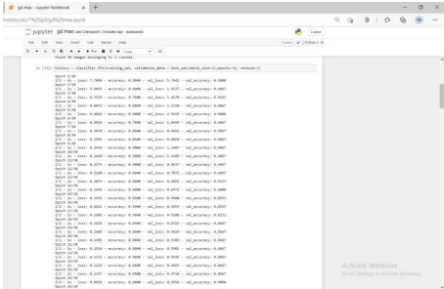

**Here you can see the training accuracy and test accuracy. And The second one is the**

**performance evolution like it show the loss and accuracy. you can also seethe model loss**

**graph**

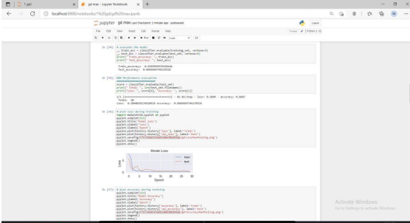

**Here you can see the model accuracy rate and graph. You can see whether themodel is**

**loaded or not by the following command**

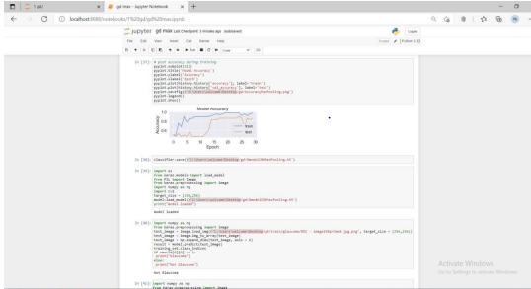

**Here we can given an input image from the database. It predicted that theimage has**

**no glaucoma**

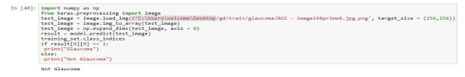

**Here we can given another input image from the database. It predicted that theimage has**

**Glaucoma**

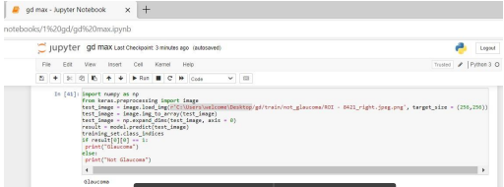

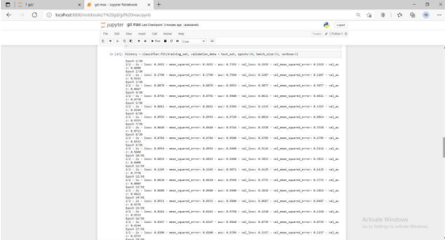

**Here you can see model mean squared error value graph and model area undercurve value**

**Graph**

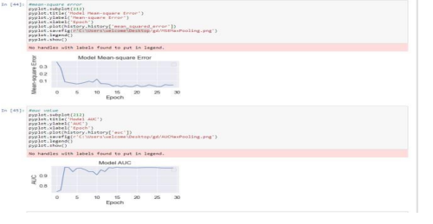

**This is the epochs calculator and gives us the values for confusion matrix**

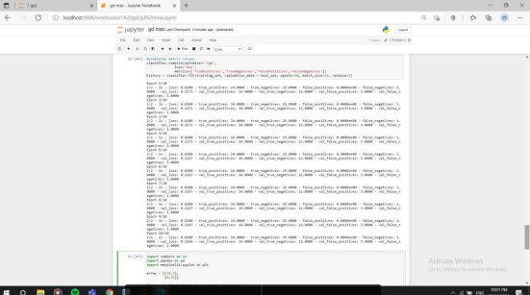

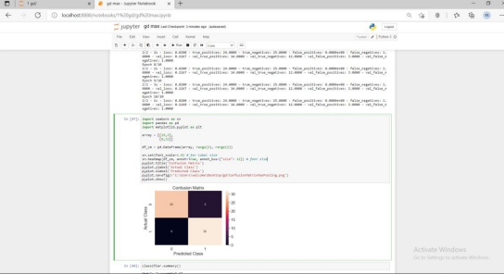

**After that we are classifying the summary**

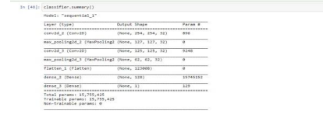

**Here we are converting all the data into a plot diagram**

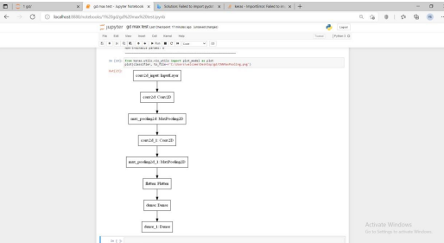

**References:**

**1. 1)Parfitt, C. M., Mikelberg, F. S., & Swindale, N. V. (2016, September). The detection**

**of glaucoma using an artificial neural network. In Proceedings of 17th International**

**Conference of the Engineering in Medicine and Biology Society (Vol. 1, pp. 847-848).**

**IEEE.**

**2. 2)Ho, C. Y., Pai, T. W., Chang, H. T., & Chen, H. Y. (2018,June). An atomatic fundus**

**image analysis system for clinical diagnosis of glaucoma. In 2016 International**

**Conference on Complex, Intelligent, and Software Intensive Systems (pp. 559-564).**

**IEEE.**

**3. Liu, J., Yin, F. S., Wong, D. W. K., Zhang, Z., Tan, N. M., Cheung, C. Y., ... & Wong, T. Y.**

**(2019). Automatic glaucoma diagnosis from fundus image. In 2019 Annual**

**International Conference of the IEEE Engineering in Medicine and Biology Society (pp.**

**3383-3386). IEEE.**

**4. Chakrabarty, L., Joshi, G. D., Chakravarty, A., Raman, G. V., Krishnadas, S. R., &**

**Sivaswamy, J. (2017). Automated detection of glaucoma from topographic features of**

**the optic nerve head in color fundus photographs. Journal of glaucoma, 25(7), 590-**

**597.**

**5. Saba, T., Bokhari, S. T. F., Sharif, M., Yasmin, M., & Raza, M. (2018). Fundus image**

**classification methods for the detection of glaucoma: A review. Microscopy research**

**and technique, 81(10), 1105- 1121.**

**6. Agarwal, A., Gulia, S., Chaudhary, S., Dutta, M. K., Burget, R., & Riha, K. (2017, July).**

**Automatic glaucoma detection using adaptive threshold based technique in fundus**

**image. In 2015 38th International Conference on Telecommunications and Signal**

**Processing (TSP) (pp. 416-420). IEEE.**

**7. Bock, R., Meier, J., Nyúl, L. G., Hornegger, J., & Michelson, G. (2018). Glaucoma risk**

**index: automated glaucoma detection from color fundus images. Medical image**

**analysis, 14(3), 471-481.**

**8. Wong, D. W. K., Liu, J., Lim, J. H., Jia, X., Yin, F., Li, H., & Wong, T.Y. (2017, August).**

**Level-set based automatic cup-to-disc ratio determination using retinal fundus images**

**in ARGALI. In 2017 30th Annual International Conference of the IEEE Engineering in**

**Medicine and Biology Society (pp. 2266-2269). IEEE.**

**9. Singh, A., Dutta, M. K., ParthaSarathi, M., Uher, V., & Burget, R. (2018). Image**

**processing based automatic diagnosis of glaucoma using wavelet features of**

**segmented optic disc from fundus image. Computer methods and programs in**

**biomedicine, 124, 108-120.**

**10. Salam, A. A., Khalil, T., Akram, M. U., Jameel, A., & Basit, I. (2018). Automated**

**detection of glaucoma using structural and non structural features. Springerplus, 5(1),**

**1519**

**CONCLUSION:**

**Glaucoma is a chronic disease and whose progression can only be stopped if detected at an early stage. CDR measurement is an important structural change that is being used in autonomous glaucoma detection systems. The adaptive threshold based technique for the automated segmentation of optic disk and cup can be useful in the early detection of glaucoma to curb permanent loss of vision. The thresholding technique used in this paper is robust and effective because it uses the image features like mean and standard deviation and does not depend on factors such as image contrast, brightness, intensity of light etc. Automatic image analysis based system is proposed for detection of glaucoma from the digital fundus image using wavelet features from the segmented optic disc. In this there are some noisy blood vessels and they are removed from the segmented optical disc and the features were extracted from this de-noised image.**